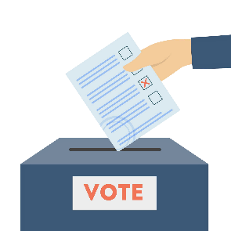

1 Vote by dropoff

> Receive your ballot

> Fill it out

> Drop it off
At a drop box
Or at a polling station

OR

2 Vote in person

> At a polling station
Early
Or on election day

Do NOT send you ballot
via US Mail

What our United States should and must stand for:

Eliminate "poverty" -
Our low-income neighbors and friends need not live in "poverty". Government policies should and must "raise the floor" - enable even the poorest to avoid poverty by having access to all of these: shelter; healthcare; food; clean water; high-quality education; and transportation.

Restore fiscal responsibility -
reduce the deficit to a surplus,
and then reduce the federal debt.

Restore the Constitutional
checks and balances
for our democracy:
Benjamin Franklin told Elizabeth Willing Powel that we had
not a monarchy but
"A republic, if you can keep it."

Restore our US as a "Shining city on a hill" - a beacon of hope and freedom.

Paid for by [paying organization]



Vote for

[candidate]

for

[office]

Affordability
Healthcare
Democracy

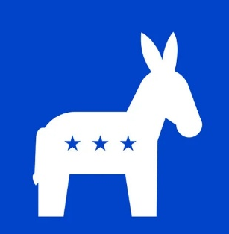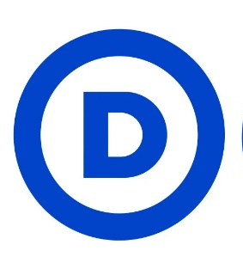

Democratic Commitments
Lower, rational tariffs
Negotiate end of Iran war
Reduce deficits>lower interest rates
Raise the minimum wage
Universal health care
Lower total costs, better results
Rational, humane deportation policy
Appropriate legal immigration level
Restore fair progressive taxation
Remove loopholes favoring the rich
End gerrymandering
Remove presidential immunity Term limits for elected officials
Direct election of the President, VP
Political donations only by people
Money is not "speech"
Eliminate income cap on SS taxes
Slow the growth rate of benefits
Smartly improve govt efficiency
Restore fair progressive taxation
Retire old weapons technologies
Invest new weapons technologies
Keep defense and budget in balance
Universal childcare birth to school
Transition from oil to renewables -
Lower cost, stronger resilience, independence from global prices
Restore EPA, FDA, USDA, NOAA
Support Ukraine and other allies -
"Shining city on a hill" -
Beacon of hope and freedom

Issues
Affordability

Healthcare

Immigration and Deportation

Taxation

Democracy at Home

Corruption

Social Security

Federal deficit and debt

War and Defense

Child Care
Energy

Clean Air, Water, Food
Democracy Abroad and
trusted US leadership in the world

Republican Failures and Plans
Prices UP, Inflation UP, due to:
Tariffs
Unnecessary Iran war
10% more federal debt in 20 months
Higher healthcare costs
Loss of insurance, subsidies
Inhumane deportation policy
Deaths, detainment of US citizens
Tax cuts mostly benefited the rich and corporations
Started gerrymandering competition
Presidential immunity: a "king"

SuperPACs, corporate funding
Profiteering from government office
Privatize Social Security

Reduce taxes, increase expenses
Added $3.9 trillion debt 20 months
Iran war weakened US
Plan 50% defense budget increase will break the budger
Can't afford day care
Increase dependence on fossil fuels
Risk fossil fuel disruptions

Weaken EPA, FDA, USDA, NOAA
Abandon Ukraine
Favor Russia, China, North Korea

